EXPERIMENT 10
TRIGGERS

Aim:
- Create a table with attribute sname, and another table with newname.
- Create a trigger to insert into second table before inserting in first table.
- Create a table for account details with attributes account number and an amount.
- Create a trigger to check if amount is negative or greater than zero before inserting to table.
Queries:
- Create a table with attribute sname, and another table with newname.
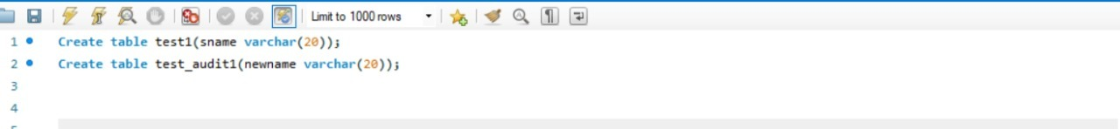
- Create a trigger to insert into second table before inserting in first table.

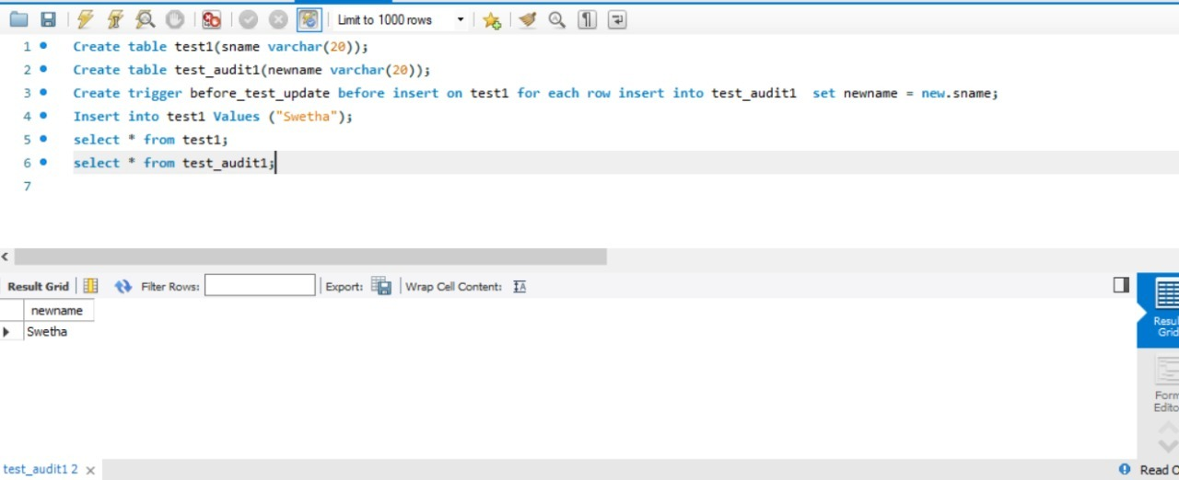

- Create a table for account details with attributes account number and an amount.
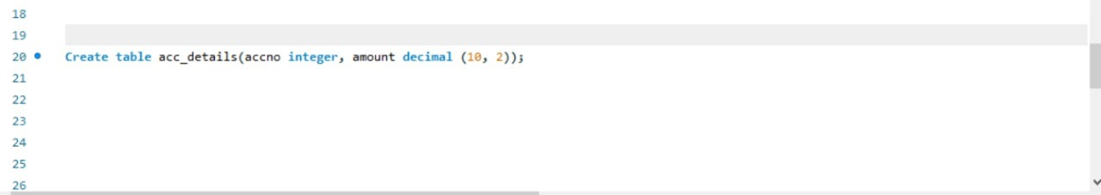
- Create a trigger to check if amount is negative or greater than zero before inserting to table.
